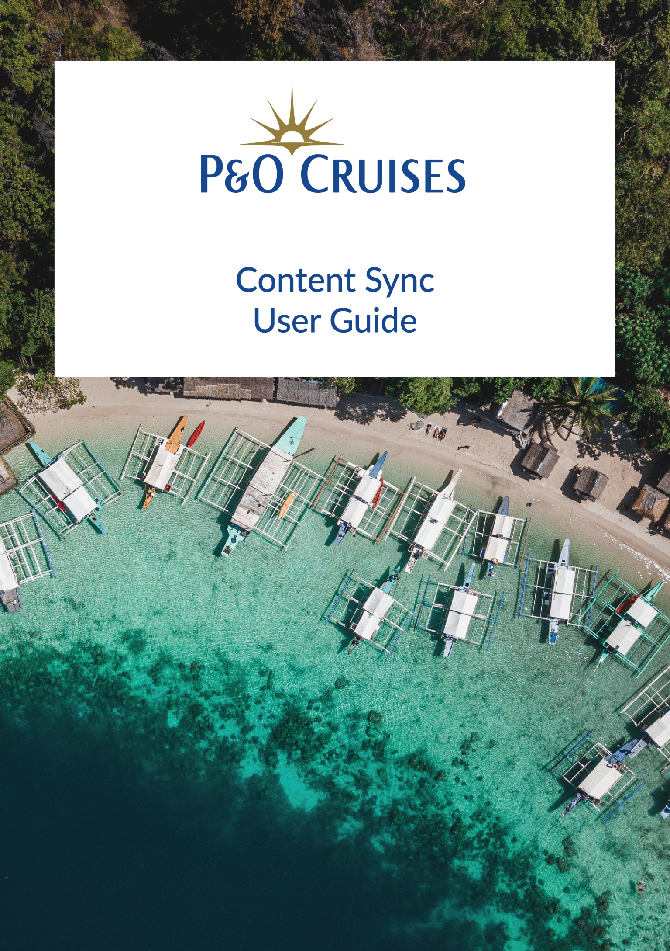

**Content Sync Module**

Shore side application whose main function is to sync text and image content for the Shorex masters currently being authored in Adobe Experience Manager shore side for ingestion by the Kiosk Control Centre on the ship.

All content displayed by the kiosk will be as authored within AEM. The system shall carry out authenticity checks of all content data extracted to avoid the possibility of bogus content being displayed at the kiosks, possibly with malicious intent. The shore excursions content (text, images) displayed by the kiosk service shall be sourced unchanged, which is extracted from the AEM Sync.

Table of Contents

1. Login Page 4

2. Dashboard 5

3. Carousel CMS 7

4. Reset Password 11

# 1. Login Page

You can use the Login screen to enter the appropriate email address and password to **login**.

If you forgot your password, enter your email address and use "Forgot **Password?**" link to recover the password.

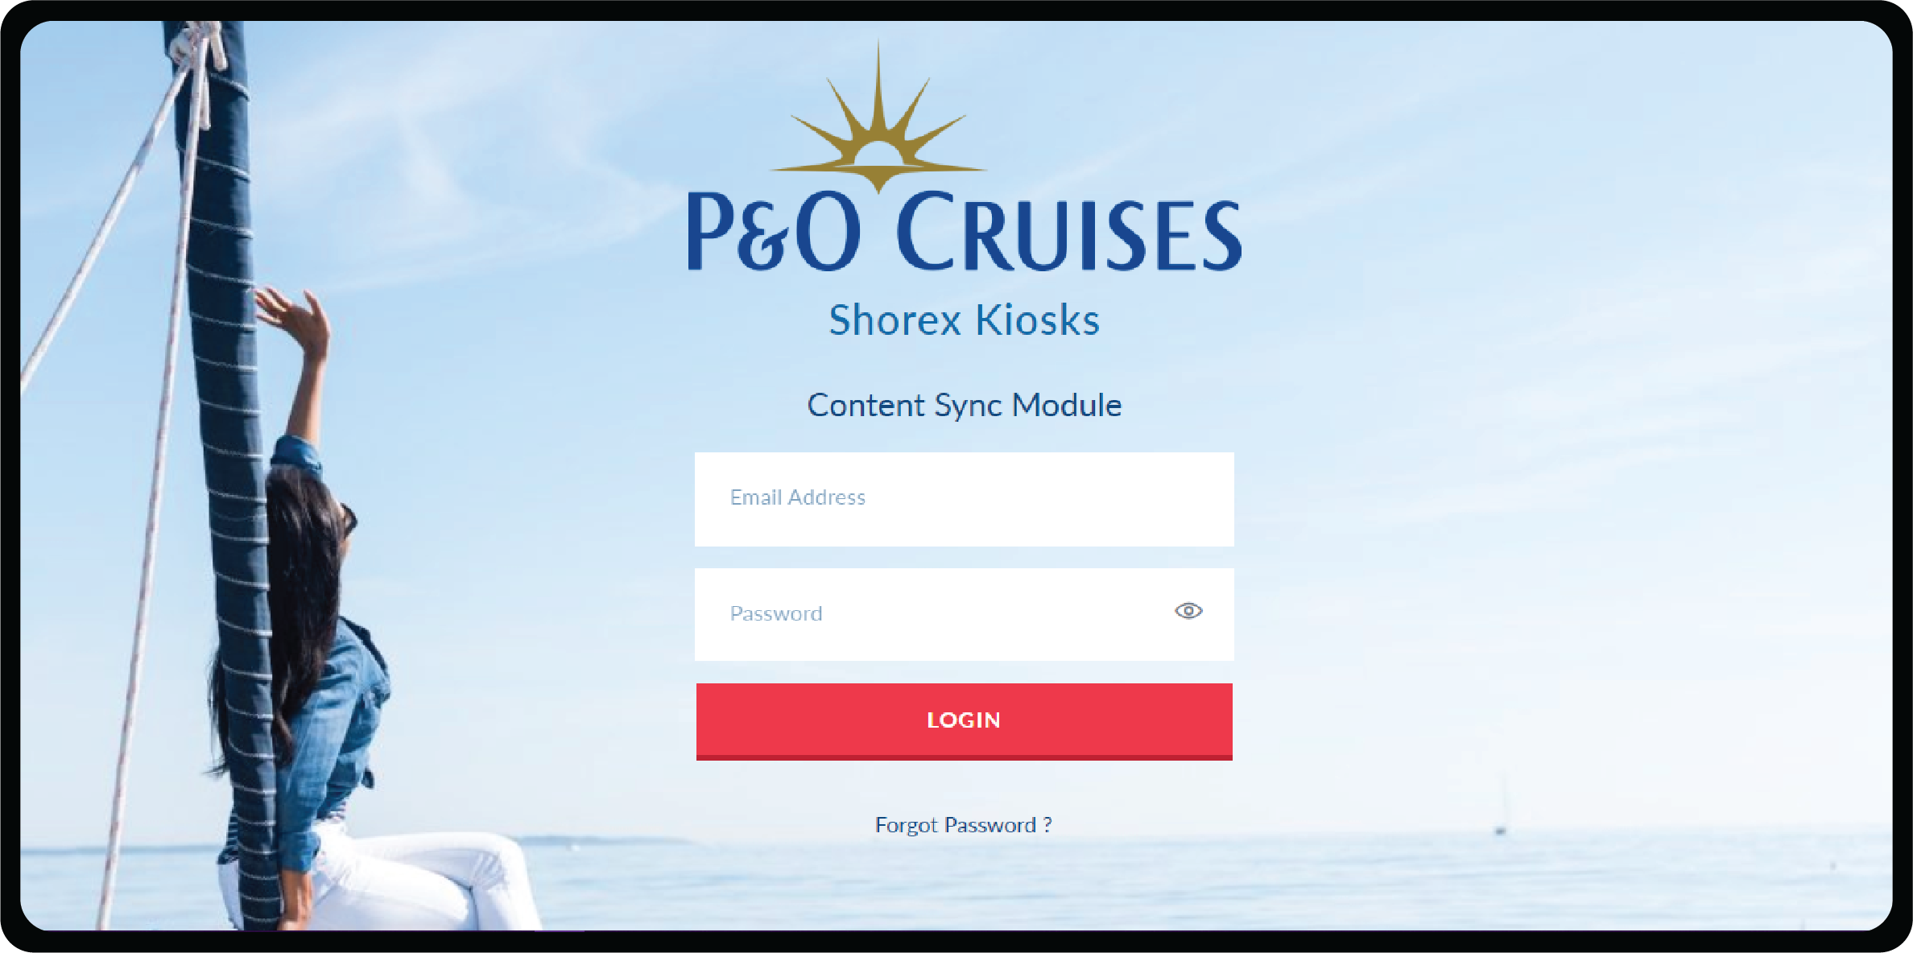

# 

# 2. Dashboard

The dashboard section has the details on Content extraction History.

You can perform the following actions on this Page.

**Perform On Demand Download:** The On Demand Download can be used to perform Asset extraction on a need basis.

**Asset Download:** Asset Download can be used to download the asset of a particular extraction.

**Content Download:** Content Download can be used to download the content of a particular extraction.

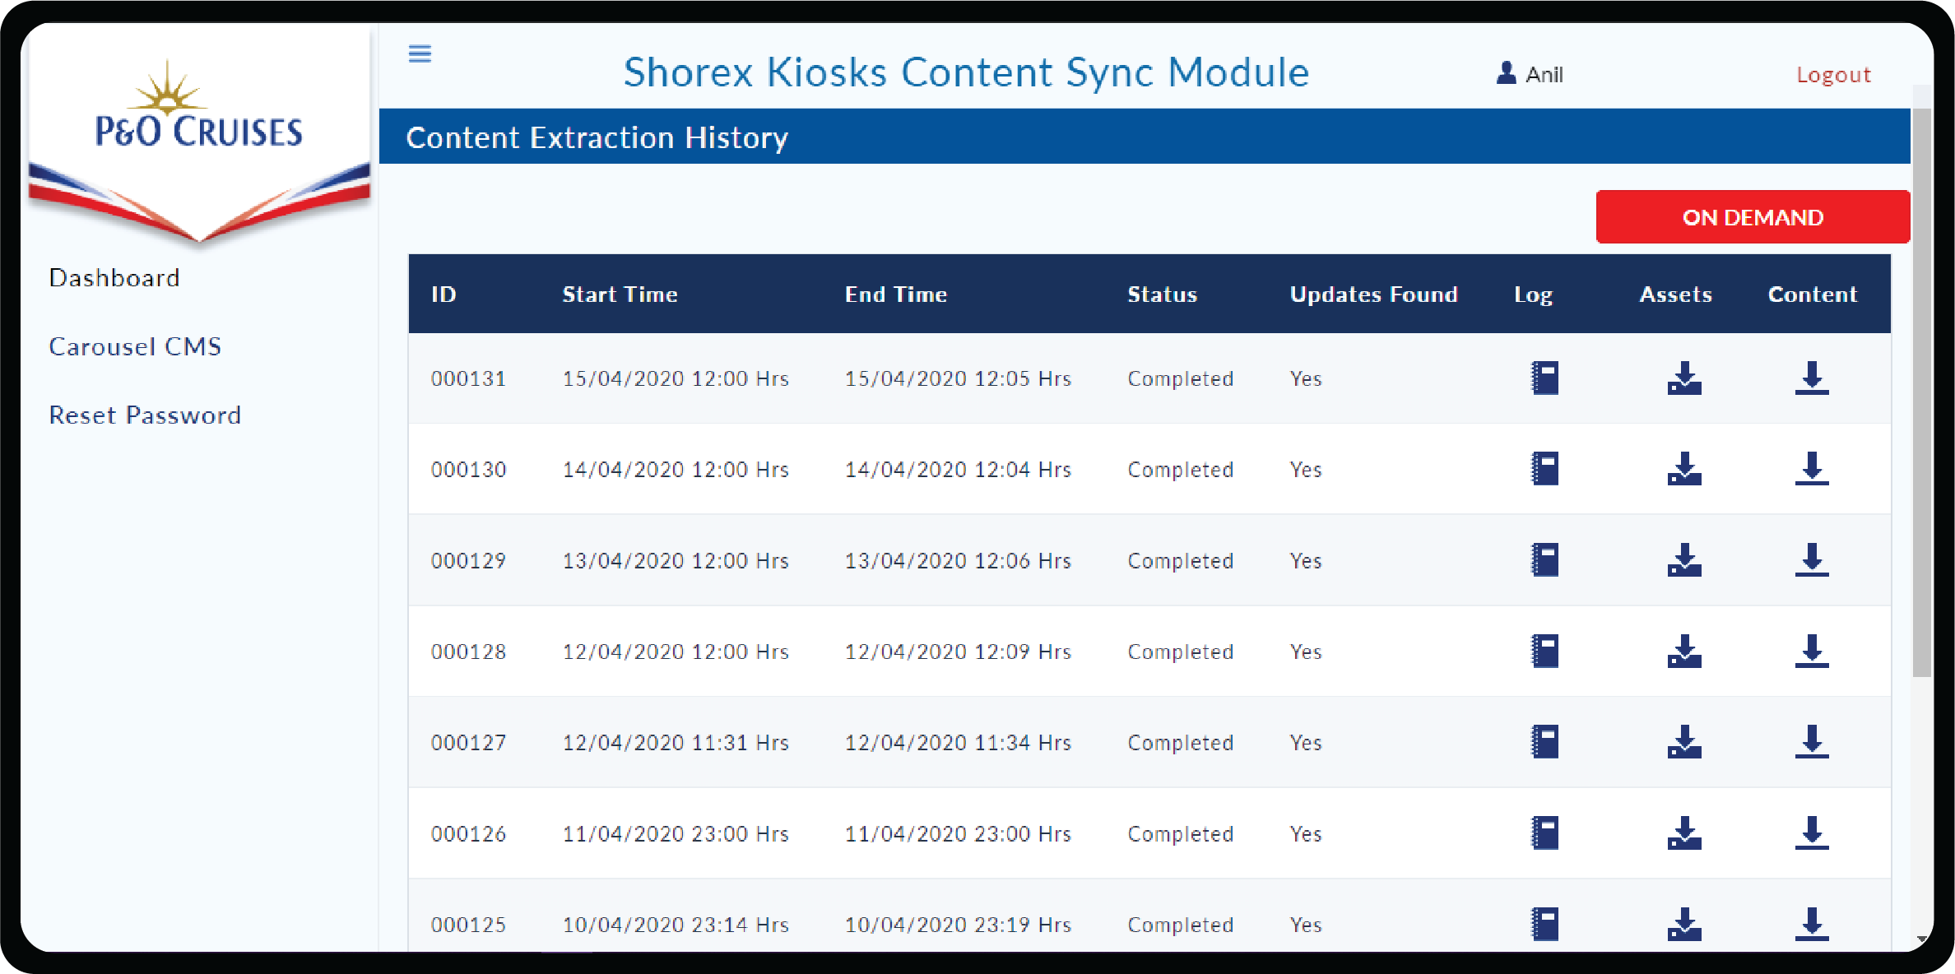

**View Log:** View Log can be used to view the attribute changes for each of the excursion for a particular extraction history.

Check the tick box to get the tour details which has missing data.

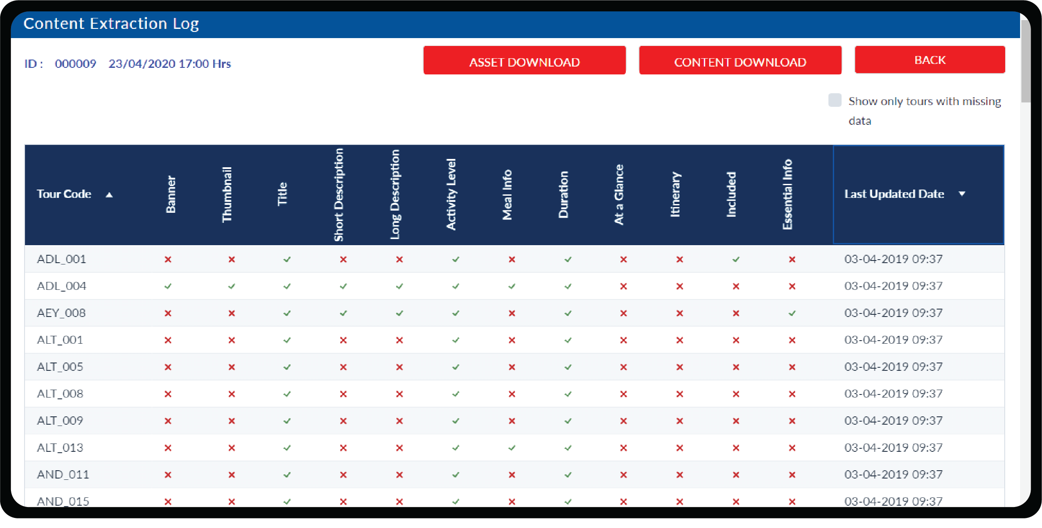

# 3. Carousel CMS

This page is for managing the Carousel Images and Banner Images.

Images uploaded in the table have to maintain a particular size **(1824x1830px)** to contain.

To delete the unwanted images from the table click on **Delete icon.**

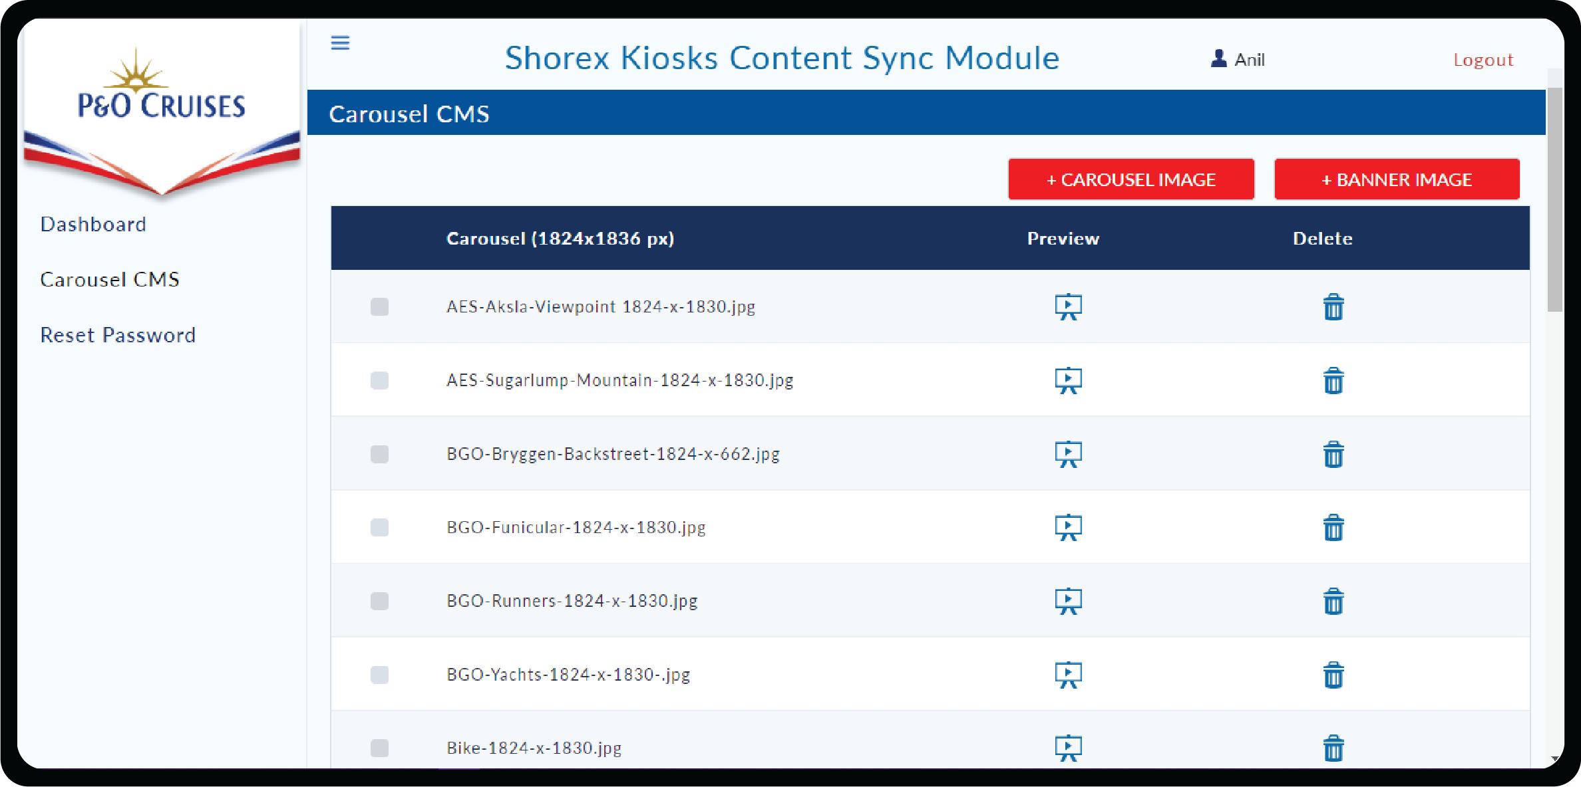

**Preview icon** is used to preview the uploaded image and can be closed by clicking outside the image after viewing.

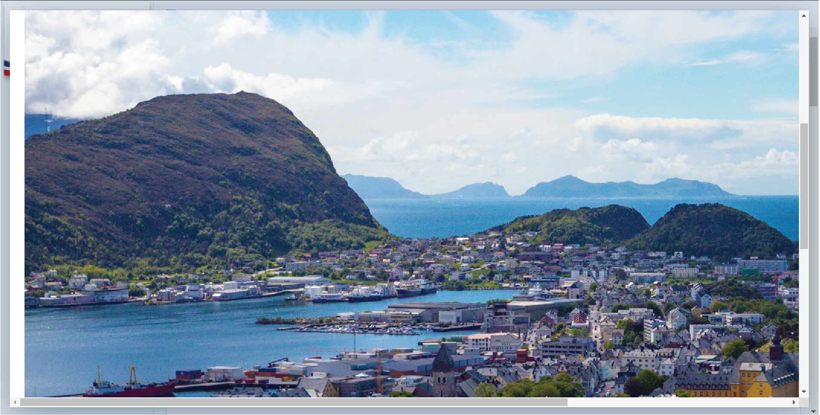

You can perform the following actions on this page.

**Add Carousel Images :** You can click on **+CAROUSEL IMAGE** to upload Carousel Images to Content Sync CMS by clicking **Upload File** button or drag and drop method and click on **Submit** button.

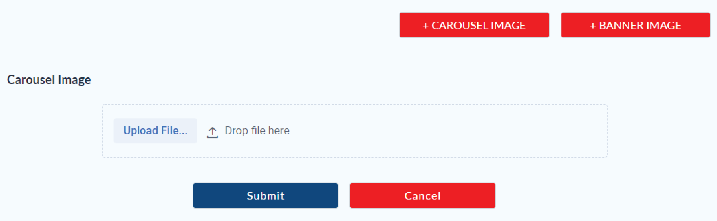

**Save Carousel Images:** You can rearrange the Carousel image by drag and drop. Click on **Save** button for Import (in Control Centre).

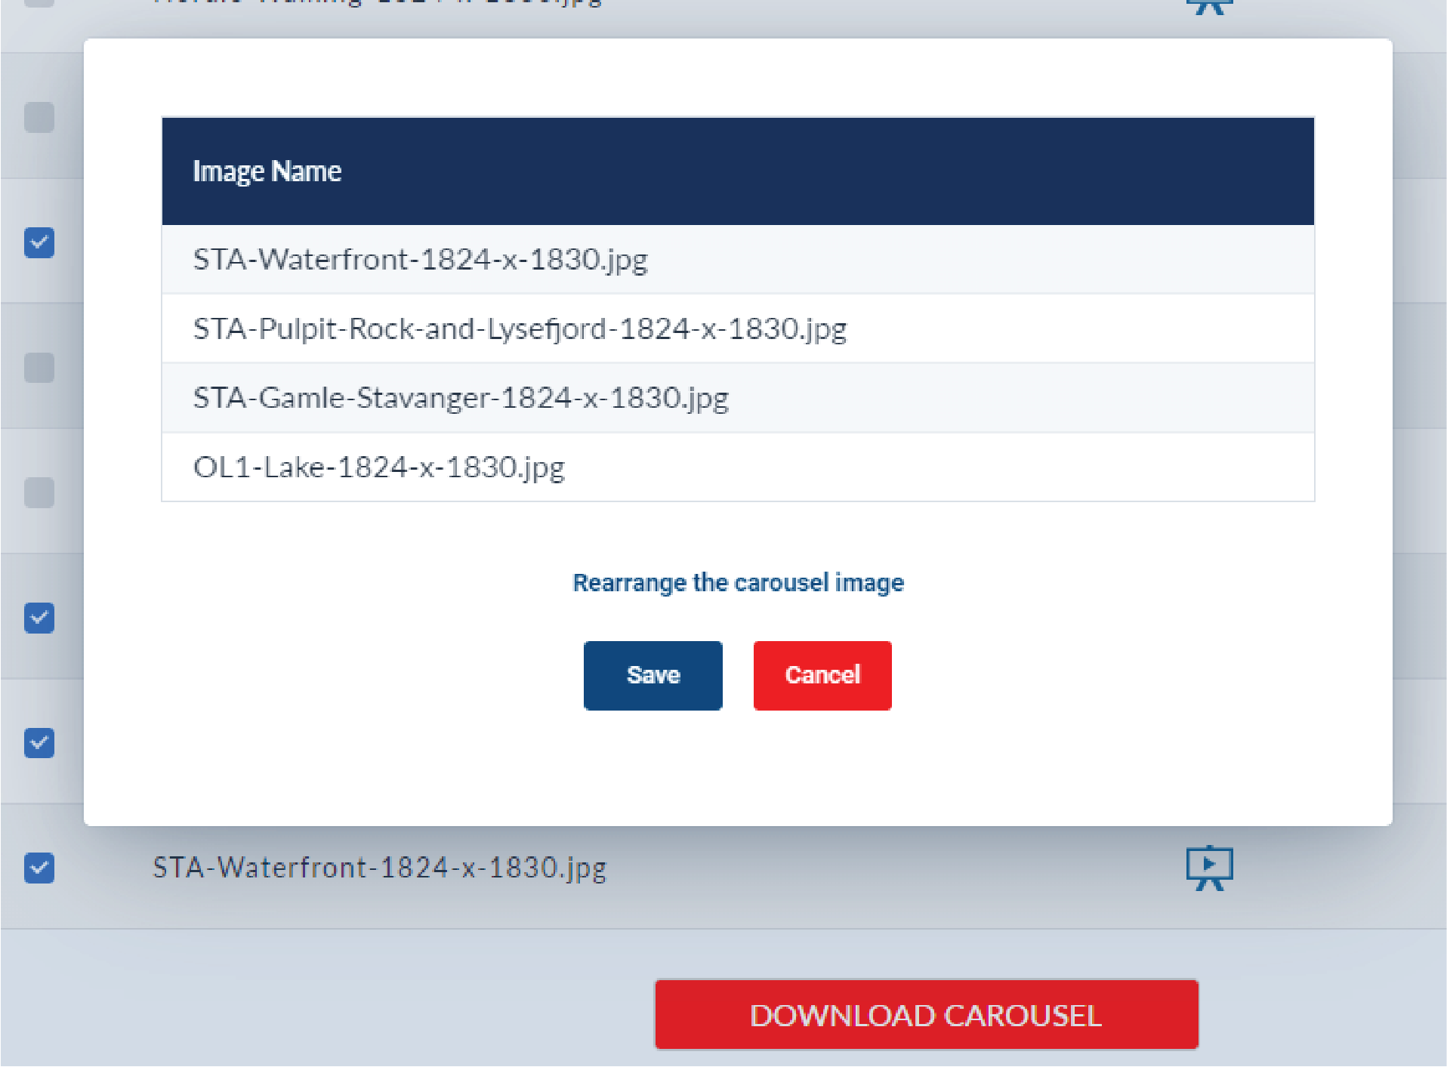

**Download Carousel Images:** After clicking on **Save** button a confirmation box will pop-up whether to download the selected file or not. Click on **Download** button to download the image bundle or cancel by clicking on **Cancel** button.

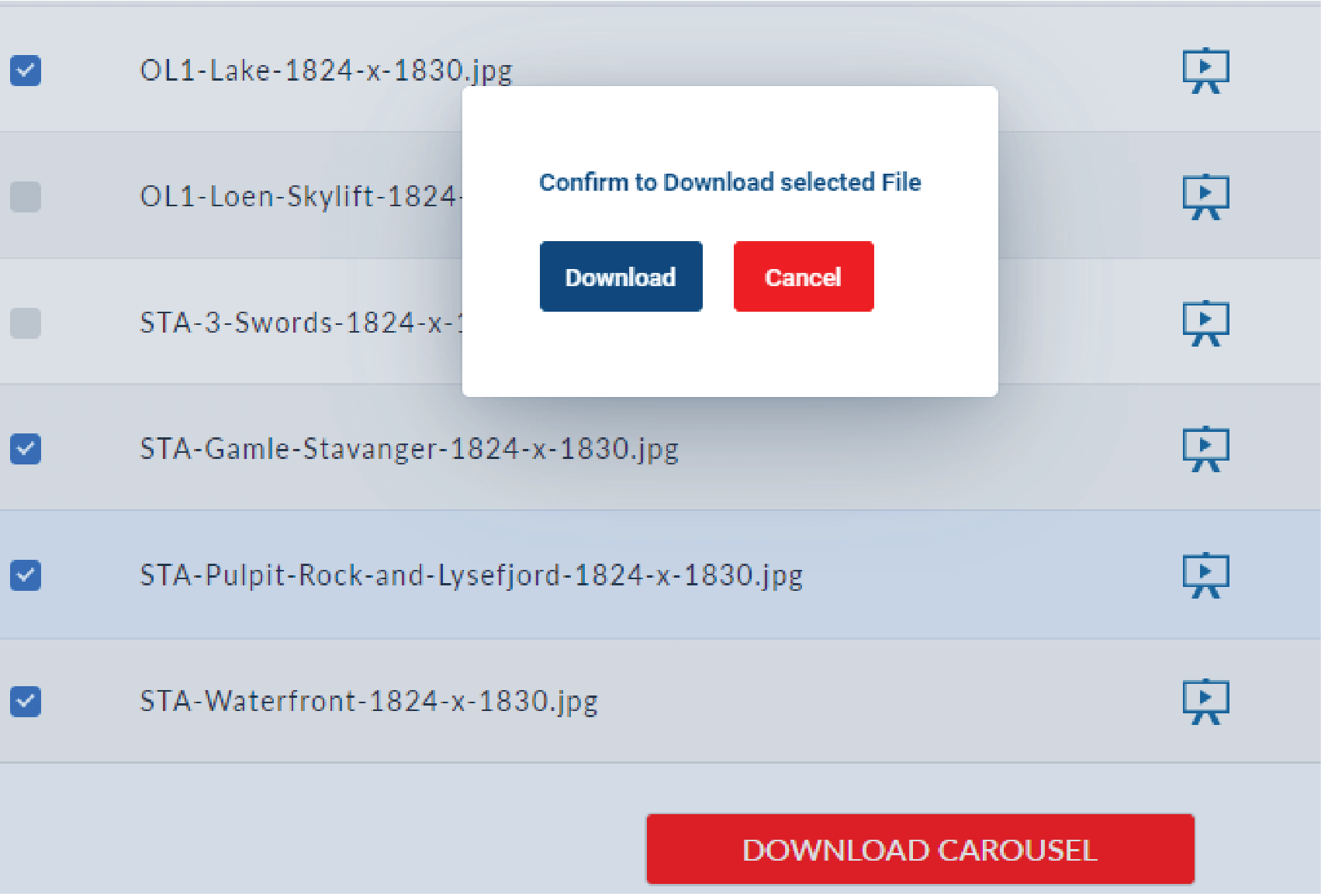

**Add Banner Images :** You can click **+BANNER IMAGE** to upload Banner Images to Content Sync CMS by clicking on **Upload File** button **or drag and drop method.**

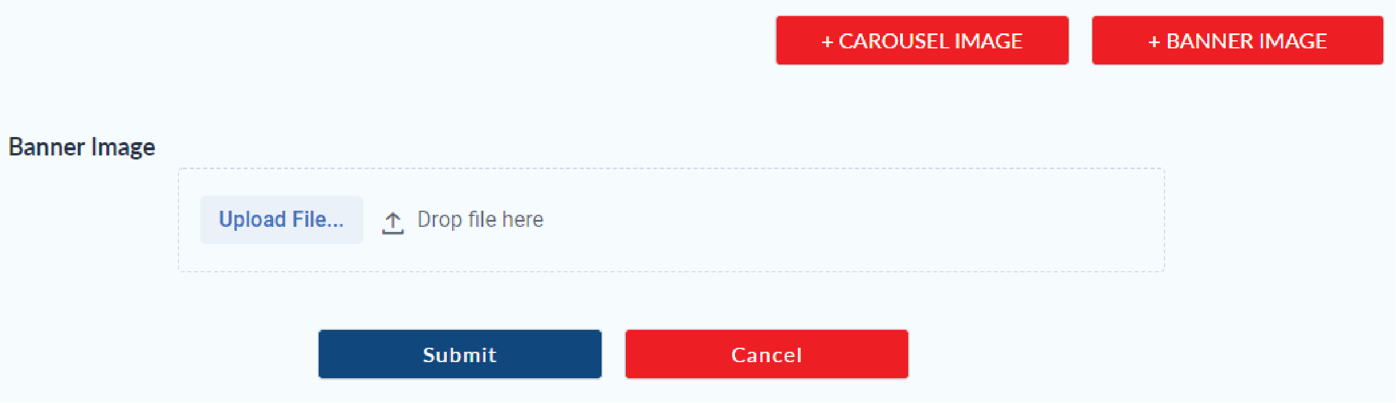

**Download Banner Images:** You can download Banner Images for Import (in Control Centre).

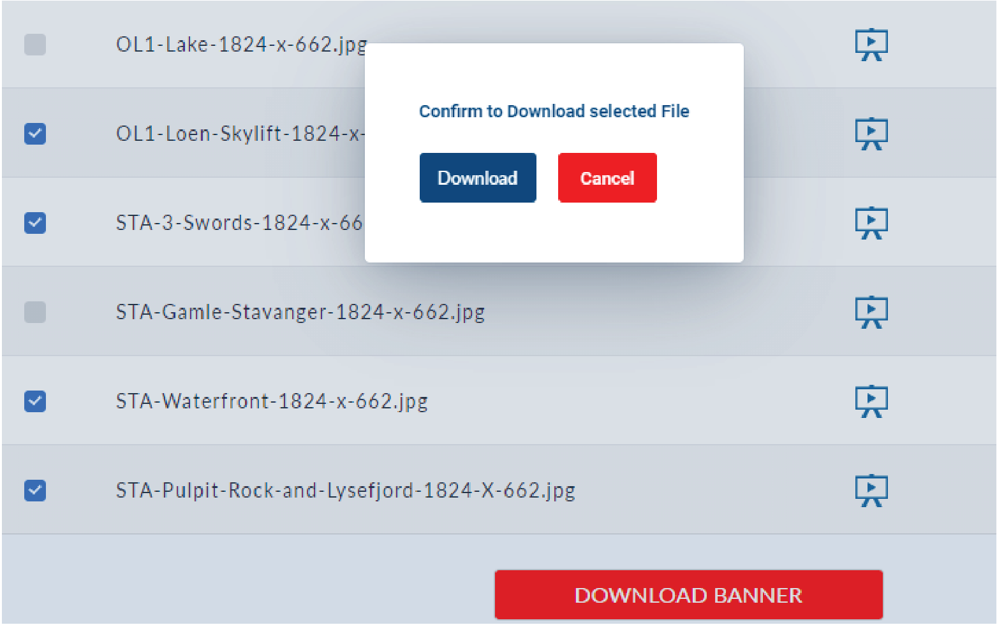

# 4. Reset Password

Reset Password, facilitates the logged on user to change the password.

In order to reset, you need to enter Current Password, New Password and Confirm Password and click **Reset** button. You can login with new password during the next login.

